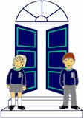
September 2020
Year 3 Healthy Break

Dear Parent/ Guardian,
This year, as in Year 1 and 2, a healthy snack will be provided for your child at a cost of £2.50 per week. Snacks are eaten in class before going out to play and vary each day, including foods such as fruit, vegetables, cheese and bread based products e.g. pancakes, toast, breadsticks/crackers etc. This snack will be prepared in line with Food Hygiene Standards.
Year 3 can avail of snack from Monday 31st August 2020. Healthy Break should be paid via the School Money App:
https://login.eduspot.co.uk/public/portal/parent/?app=schoolmoney&source=website&version=20190314
The total cost for the first term is £22.50.
Milk notes will be going out soon, however please send a drink of water for your child in a named bottle to have at snack time as juice is not allowed, in line with our Healthy Breaks Policy.
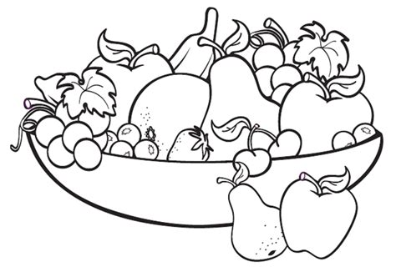
The healthy break payment also helps to cover costs for resources that will be used for science experiments, baking, class parties etc.

Many thanks for all your support,
Year 3 Team

