Mill Strand Integrated Primary School
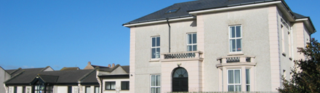

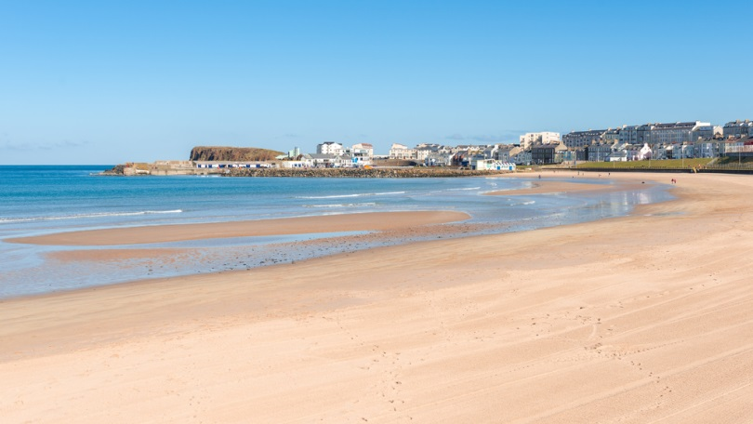

Nursery
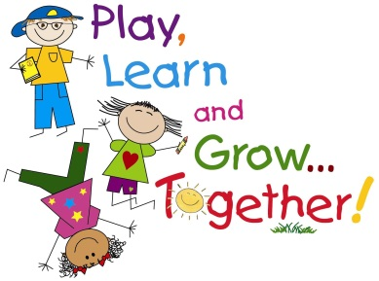
Information Pack

NI Curriculum

Aims of the Nursery Curriculum
Nursery education aims to develop the whole
child by:
• promoting emotional, social, physical, creative
and intellectual development;
• developing self-esteem, self-control and positive
attitudes towards others;
• developing language and communication skills to
encourage the sharing of thoughts and feelings; and
• creating confident, eager, enthusiastic,
independent, curious learners with a positive and
problem-solving attitude to learning.
We believe young children learn best when:
• they feel happy and secure in a safe and
stimulating environment that supports their
well-being;
• adults are sensitive and understanding in their
interactions with the children while extending
their learning and development;
• the curriculum is broad and balanced, builds
on their needs, and provides time for sustained
involvement in play;
• they have opportunities to investigate and engage
in a wide range of activities that are enjoyable,
motivating and challenging;
• the activities are based on previous learning and
are carefully planned, with some flexibility;
• they have the opportunity to develop
concentration and skills such as observing,
making decisions and problem-solving; and
• parents/guardians/carers and other professionals
work together in partnership.
Areas of Learning
- Personal social emotional Development
- Communication and language
- Early Maths
- World Around Us
- Creative Development
- Physical Development
Personal, Social, Emotional Development
- Turn taking and sharing
- Making lots of friends and cooperating with others
- Following Nursery rules and routines
- Becoming independent
- Persevering when something is difficult
- Building Self Esteem and Confidence

Communication and Language
- Talking and listening
- Reading stories and browsing
in the book corner
- Writing and mark making

Early phonological awareness
- Developing attention and listening skills
- Identifying words and pictures in the
Environment
- Identifying sounds in the environment
- Playing with words and beginning to recognise similarities in words e.g. rhyming words and words with the same sounds
- Beginning to identify and hear the sounds
in words
Early Maths
We:
- sort
- match
- count
- recognise some numbers and shapes
- compare
- make patterns
We do it through….
- Playing
- Exploring
- Investigating
- Doing and observing

World Around Us
We learn about science, history and geography through hands on practical experiences. All of our topics are based on children’s interests and ideas!
We have visits from doctors, dentists, vets, postmen, RNLI people and lots more!
Outdoor Classroom
- Mill Strand is an outdoor school and we use our outdoor areas and local environments whenever possible.
- In Nursery we have outdoor learning for at least 1 hour each day
- We have a poly-tunnel and vegetable patch where we grow our own food, a mud kitchen, role play house, climbing frame and lots more outdoor equipment to extend our learning.
- In the summer term we buddy up with Yr 6 children and take our learning to the beach each week
- We go on train rides, bus trips, library visits and picnics. We even walked to post letters to Santa Claus!

The Arts
Children are given a wide range of opportunities to develop their creative abilities in art, craft, role play, music, singing and drama activities each day, inside and out!

Physical Development
The children are given lots of opportunities to develop their gross and fine motor skills indoors and outdoors. We also have a ‘PE and Movement’ session in the school hall each week. We have regular dance, yoga sessions and dough disco sessions too.
We help children to develop these skills by
- Threading beads
- Using scissors and tools
- Climbing
- Balancing
- Using bikes and scooters
- Moulding playdough
- Developing our finger strength by writing in salt, shaving foam and messy materials
ICT
Our classrooms are equipped with touchscreen interactive whiteboards and iPad. Children are able to access these each day and develop their ICT skills to access educational games.

We incorporate all of this learning into our half termly topics.
Some topics we have covered are:
- All about me, Space, Journeys, Growing, Castles, Pets, The Jungle, Bears, Seasons, Mini Beasts, Light and Dark, Holidays
Observing, planning and Assessment
We use ‘2build a profile’ iPad app to record children’s progress and achievements and create individualised planning and learning opportunities for each child based on their personal skills and knowledge.

Useful information
- About the Curriculum – www.nicurriculum.org.uk
- About Mill Strand IPS – www.millstrand.co.uk
- Check out our Facebook and Twitter page

